

**CHESHIRE’S CHURCHES**

**& CHAPELS OPEN DAY**

**14th SEPT.**

**2019**



Contact details :

**and Visit our website www.hccpt.org**

Sponsored by the National Churches Trust

Charity Number1119845

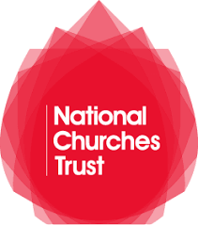

**www.rideandstrideuk.org**

**Join us for a sponsored cycle ride, walk, horse ride, run, car trip or mobility scooter dash and visit beautiful churches and chapels to raise funds for urgent repairs. With churches across the Chester Diocese open from 10 am to 4 pm, Ride and Stride for Churches is a great way to discover Cheshire’s history and heritage. All the money you raise will be shared between the Historic Cheshire Churches Preservation Trust and a church or chapel of any denomination you nominate.**

**Join Us**